BCHPA 2021 Treasurer’s Report
Year end Oct 31, 2021

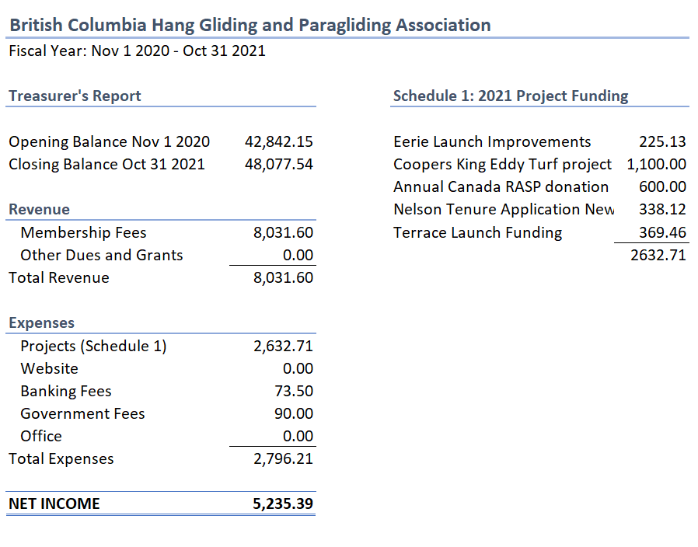
Notes
- No expenses currently outstanding
- Financials are unaudited and no assurance is expressed hereon
- Cash basis
Commentary
In 2021 BCHPA received 8,031.60 via HPAC dues collected, representing the sole association income source. For expenses, this year was quiet in terms of projects funded. A total of 5 projects were funded (including an annual donation to Canada RASP) at a cost of 2,632.71. After accounting for banking fees and society reports, total expenses came to 2,796.2. Income less total expenses results in 5,235.39 in retained earnings for the fiscal year. For comparison, in 2020, revenue was 9,632.10, eight projects were funded at a cost of 5,150.01 and total expenses came to 5,467.03.
The BCHPA ending account balance is 48,077.54 as of Oct 31, 2021.

